How to backup your iPhone or iPad with iCloud
After you back up your iPhone or iPad, you have a copy of your information to use in case your device is ever replaced, lost, or damaged. You can back up your device manually, or turn on iCloud Backup to automatically keep your device backed up.

Back up manually
- Connect your device to a Wi-Fi network.
- Go to Settings > [your name], and tap iCloud.
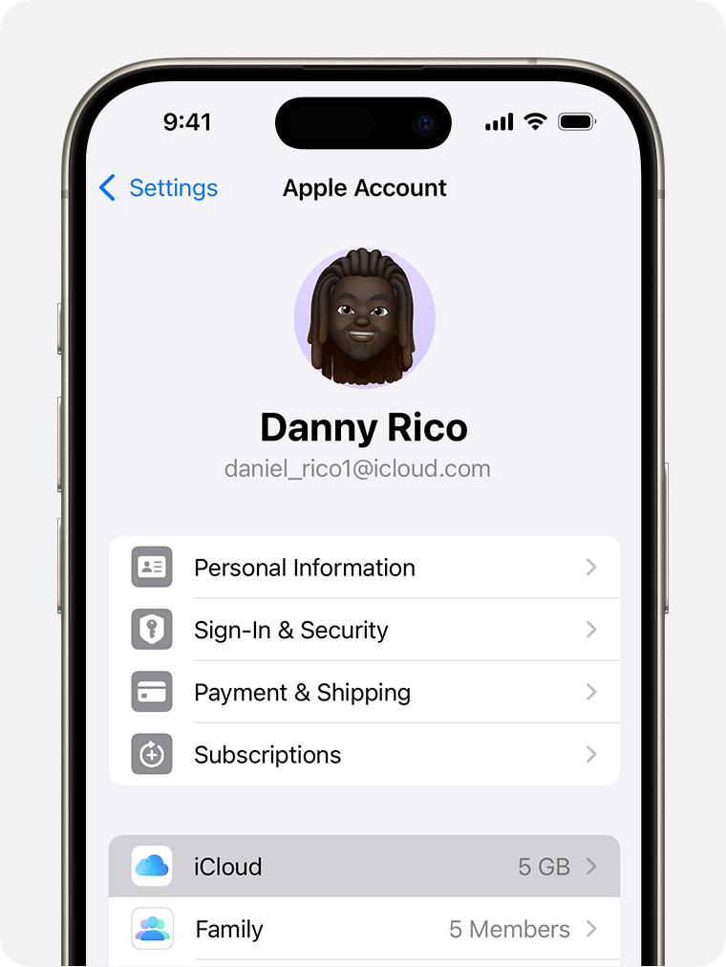

- Tap iCloud Backup.
- Tap Back Up Now. Stay connected to your Wi-Fi network until the process ends.
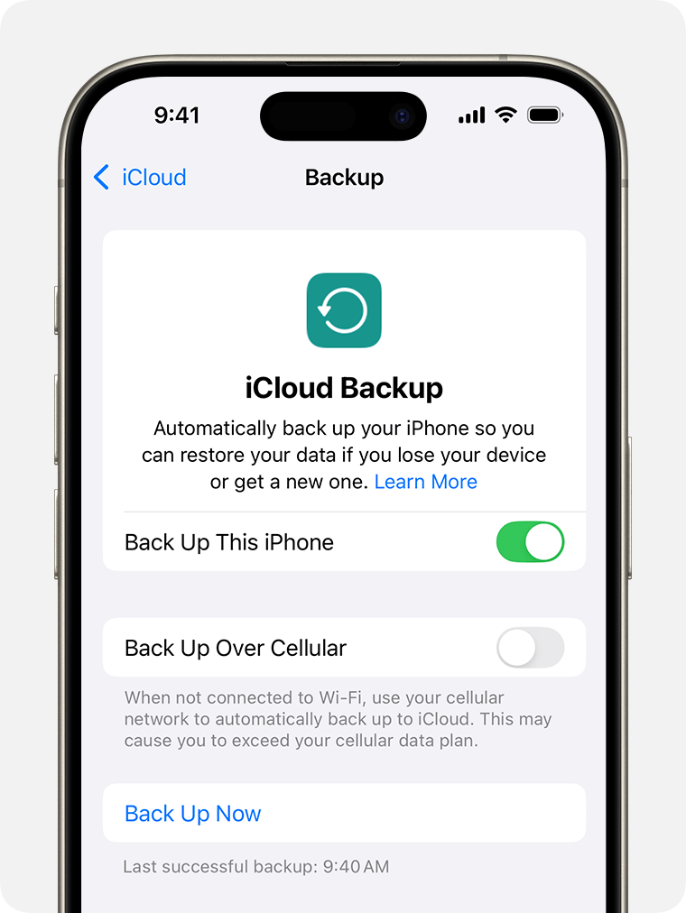

Automatically back up with iCloud Backup
- Go to Settings > [your name] > iCloud > iCloud Backup and make sure that Back Up This [Device] is turned on.
- Connect your device to a power source.
- Connect your device to a Wi-Fi network.
- Make sure that your device's screen is locked.

How to factory reset your iPhone or iPad with iCloud
- Go to Settings  > General > Transfer or Reset iPad > Reset.
- Tap Erase All Content and Settings.
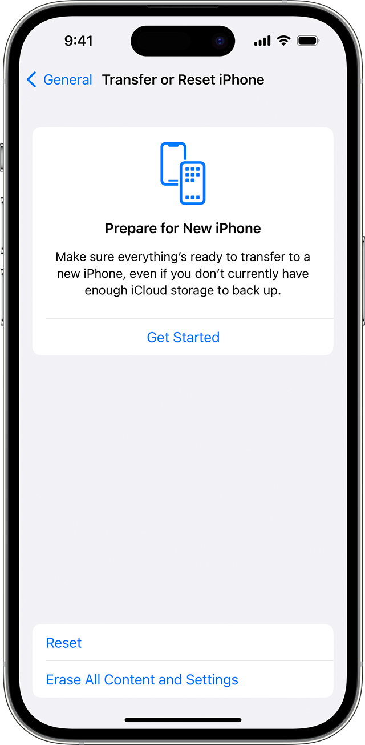
- If asked, enter your passcode or Apple Account password.
- Confirm that you want to erase your device.
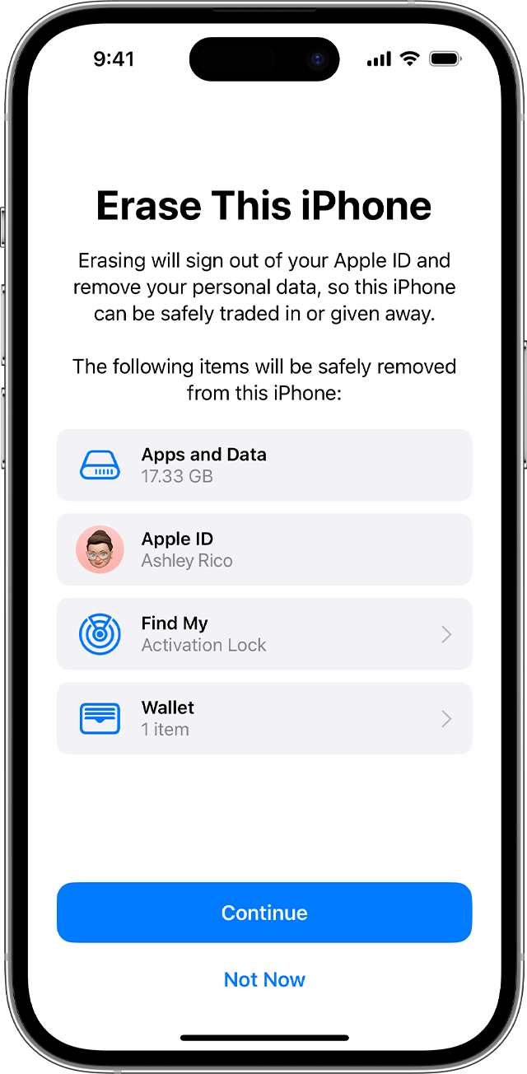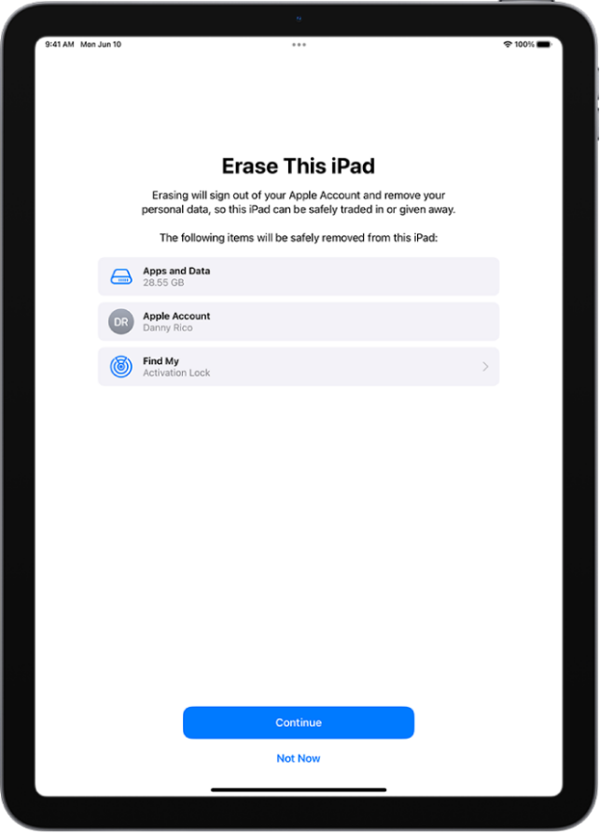
- Wait for your device to erase
  - Please note: It might take a few minutes to completely erase the data.

What if I have issues backing up or resetting my device?
If you are experiencing issues with any of the above guidance, you may reach out to our Service Desk at 866-964-5050 or helpdesk@impactnetworking.com.

